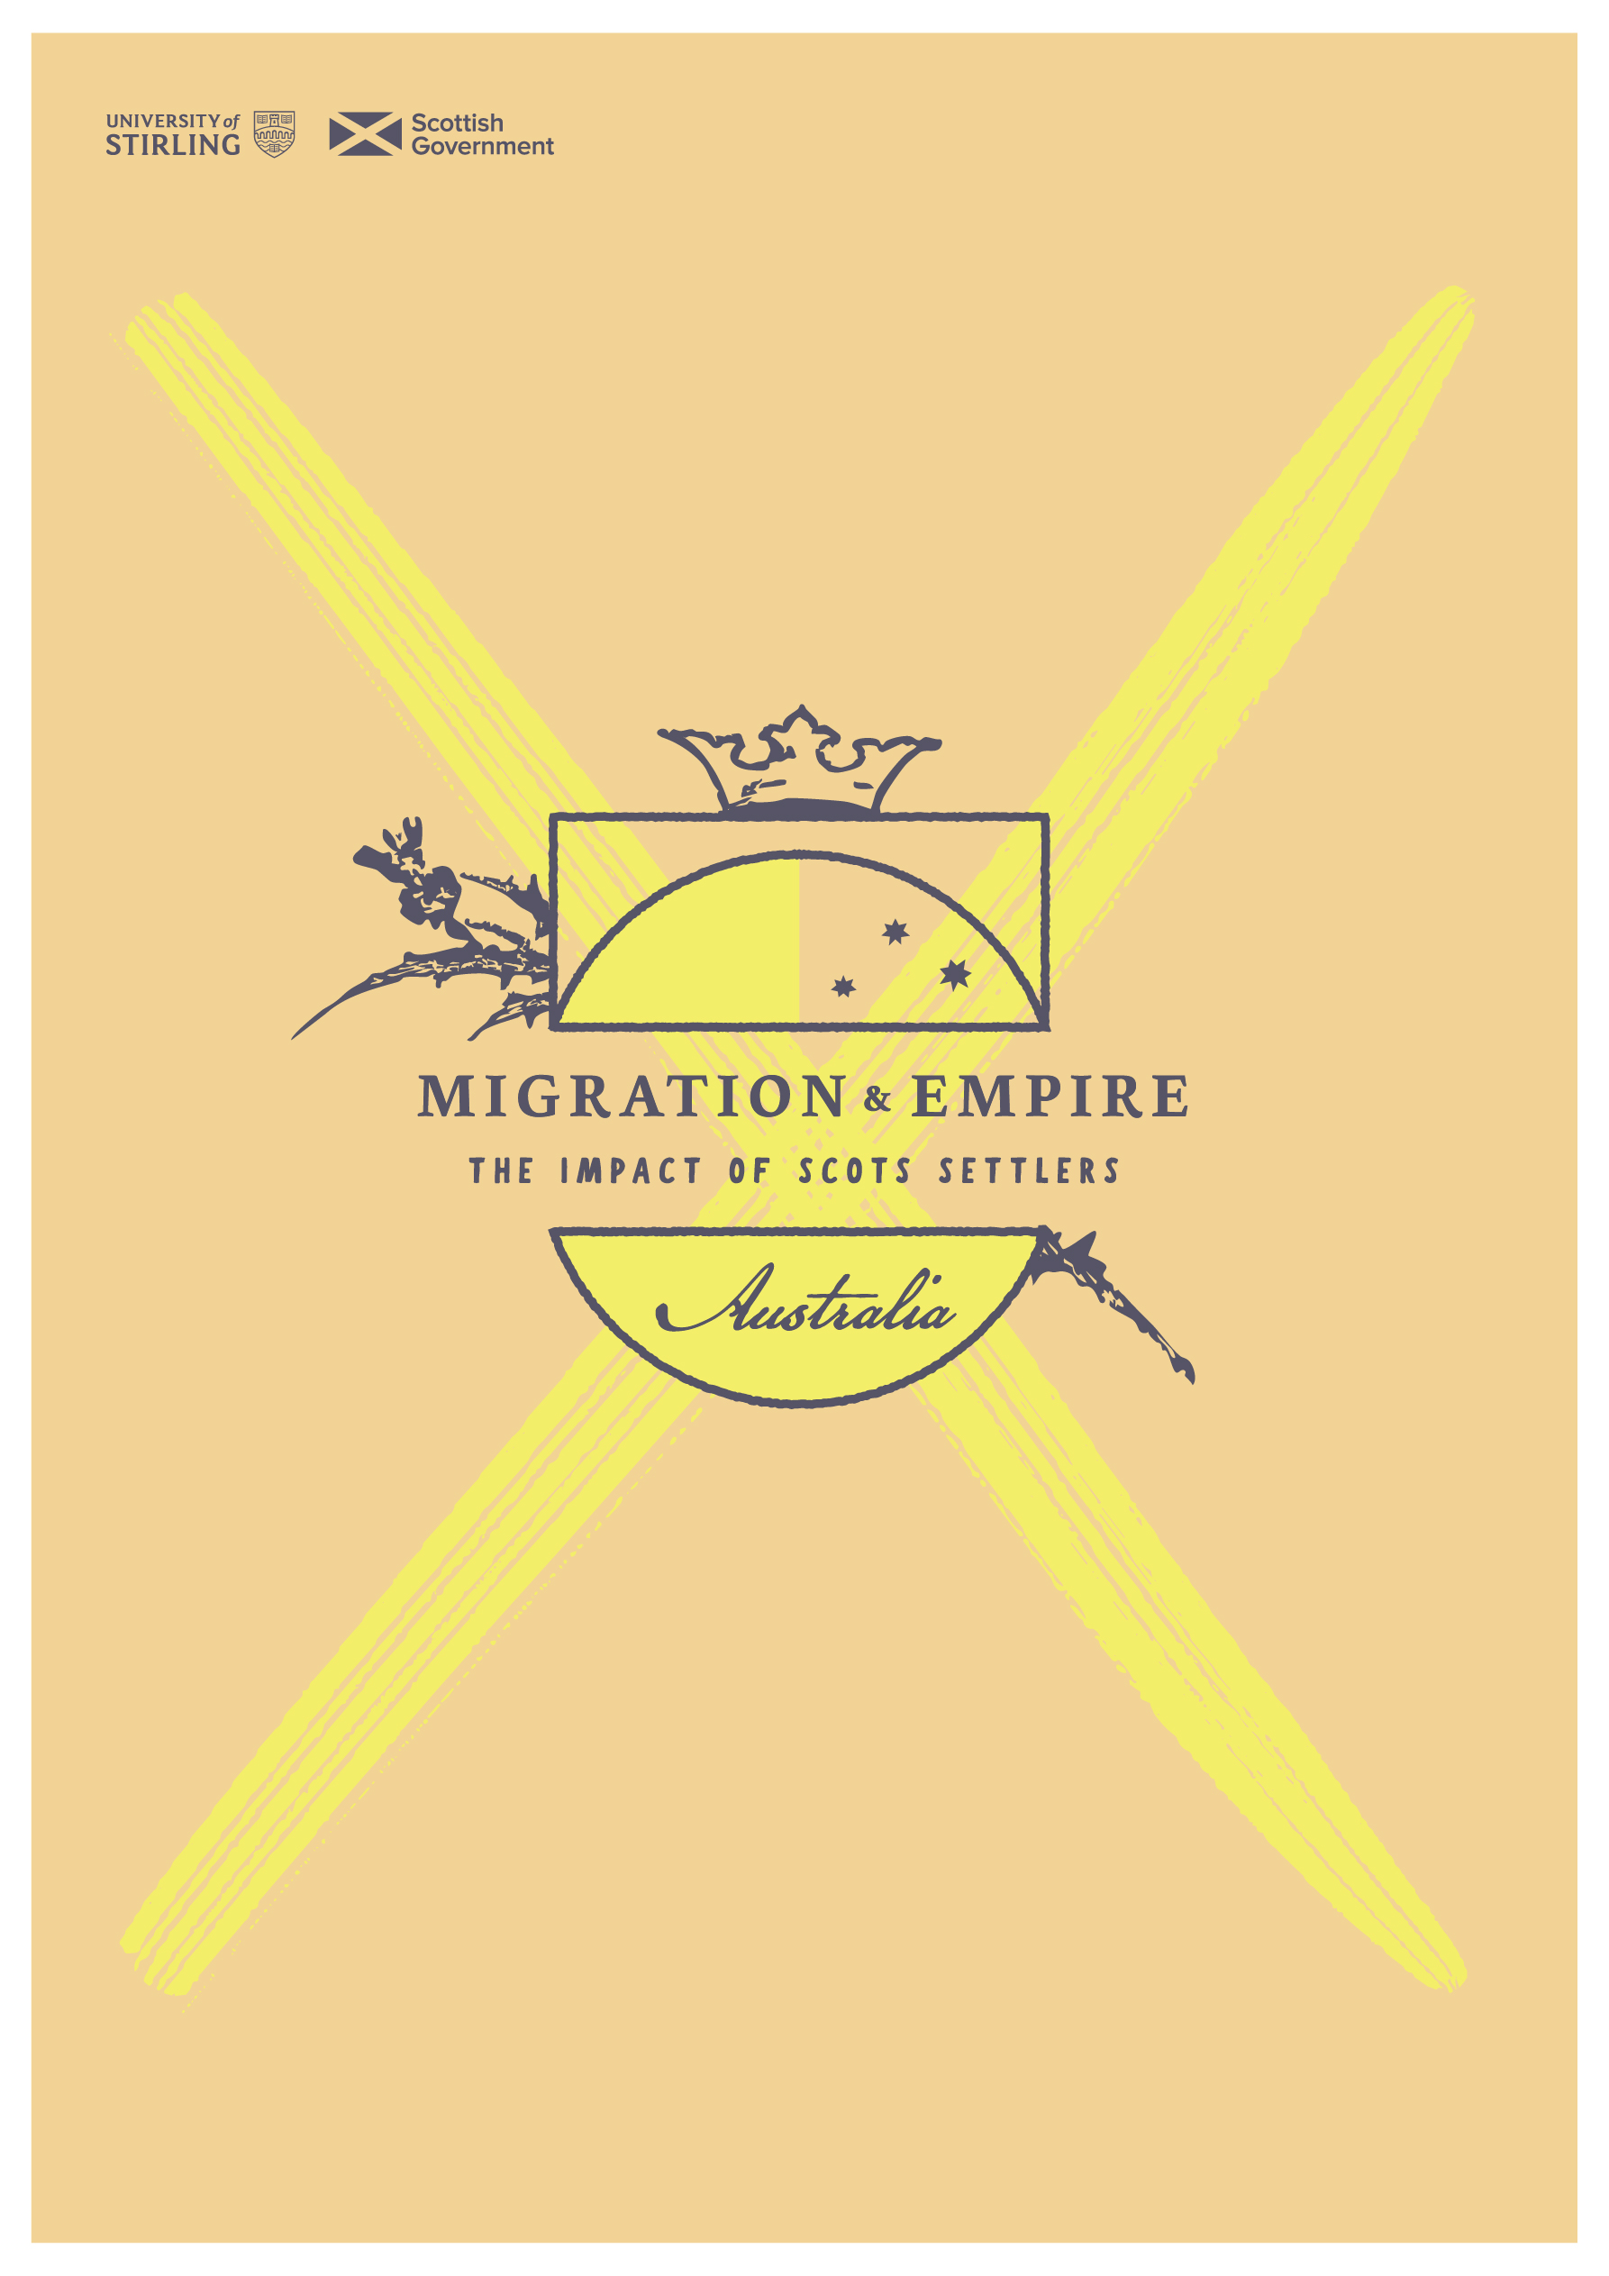
sath.org.uk/migration-and-empire
Introduction to the history of European settlement in Australia
Introduction to the history of European settlement in Australia. Adapted from ‘Indigenous Cultures and Contact History: Timeline’: https://www.nma.gov.au/learn/encounters-education/timeline, and the Australian War Memorial: https://www.awm.gov.au/articles/atwar/colonial

In 1788 British ships carrying some 1,500 people landed on the shores of Sydney Cove in Australia. That expedition, called the First Fleet, was the beginning of the British colonisation of the continent.
Before the arrival of the First Fleet, the Indigenous peoples were the only people to have lived in Australia. They belonged to over 300 different nations or groups, each with its own language or dialect, laws, beliefs, and customs.
The consequences of colonization on Indigenous Australians were devastating. Most scholars have estimated that the Indigenous population before European settlement was between 300,000 and 750,000 people. Between 1788 and 1900 their numbers were reduced by as much as 90%. This drastic decline was the result of several factors. One was the loss of their traditional territory which had sustained Indigenous peoples for thousands of years. Another was exposure to new diseases brought by the colonists. Yet another factor was violent conflict with the colonists.
Cultural Disruption
Before European arrival, Aboriginal and Torres Strait Islander peoples lived as hunter-gatherers. Each clan had their own territory, which it relied on for food, shelter, medicine, and tools. Indigenous people did not think of land in terms of monetary value, and they did not believe that they “owned” the land. Instead, they felt a deep spiritual connection to their territory, or Country.
With no signs of land ownership, such as fences, crops, stock animals, or buildings, the Europeans who came to Australia believed the land was free to claim. They called it terra nullius, or land belonging to no one. The settlers cleared land for farming and to build towns along the east coast. They fenced off the land, which restricted access to clean water, hunting grounds, and food supplies for Indigenous communities. As British settlement expanded to other parts of Australia, more Indigenous groups were forced off their traditional lands. Indigenous peoples struggled to survive, and a large number died from starvation and malnourishment.
The survivors suffered other kinds of trauma. Indigenous peoples saw many of their sacred sites destroyed by the colonists. Indigenous men and women were taken from their homes and forced to work for the colonists. The Australian cattle industry, for example, was built on the labour of Aboriginal men. Aboriginal women were forced into domestic work in settlers’ homes. Both Aboriginal and Torres Strait Islander peoples were used to do the risky work of diving in the pearling industry. Pregnant Indigenous women were preferred as divers because it was believed that they had a larger lung capacity. Another abuse faced by Indigenous women was sexual assault.
Disease
The introduction of new diseases by the colonists had a devastating impact on Indigenous communities. The Europeans brought many diseases with them, including bronchitis, measles, scarlet fever, chicken pox, smallpox, and whooping cough. Whereas the Europeans had built up a resistance to these diseases, the Indigenous population had never been exposed to them.
Within weeks of exposure, the diseases spread rapidly among Indigenous communities. It was reported that smallpox killed half of the Aboriginal people in the Sydney area within just over a year of the arrival of the British. In the Port Phillip (Melbourne) area, diseases caused up to 60 percent of Aboriginal deaths.
Conflict
The first Europeans to land in Australia were Dutch sailors in the 1600s. In 1606 Dutch captain Willem Janszoon (also spelled Jansz) and his ship Duyfken sailed along the western coast of Cape York Peninsula in search of new trading areas. Captain Janszoon and his crew landed at a place they named Cape Keerweer, which means “turn around” in Dutch. Some of his crew came across the Wik, the local Aboriginal people. According to Wik oral history, a fight broke out between the Dutch sailors and the Wik, which resulted in deaths on both sides. This was the first known conflict between Europeans and Aboriginal peoples. As a result of the conflict and because there were few tradable items, the Europeans “turned around” and sailed back to Indonesia.
The next Europeans to make contact with Aboriginal peoples were the British settlers who arrived in the 1700s. Some of the Eora—the Aboriginal peoples of the Sydney area—welcomed the newcomers. The leader of the British colony, Arthur Phillip, directed the colonists to treat the Aboriginal peoples respectfully. Before coming to Australia, Phillip had been instructed by the British king to open communication with the local people.
The governor saw benefits in interacting with the Aboriginal peoples. He wanted the colonists to learn the local language and to teach English to some of the local people. With the ability to communicate, he hoped the colonists could persuade the Aboriginal people to accept colonization peacefully. In addition, he wanted to learn about the area’s natural resources. Knowledge of local plants could help the colony deal with food shortages.
As the colony expanded, cordial relations between settlers and the Aboriginal peoples gave way to conflict. One of the earliest incidents of Aboriginal resistance happened in May 1788, when two Europeans were killed near Rushcutters Bay (now a suburb of Sydney).
The first British settlement on the island of Tasmania, then called Van Diemen’s Land, was established in 1803. The next year European soldiers fired on an Aboriginal hunting party, beginning a long period of conflict known as the Black War. As the settlers occupied hunting areas to raise sheep and killed great numbers of kangaroos, the Aboriginal Tasmanians struggled to find food. The settlers also harassed Tasmanian women and children, taking them against their will. The Tasmanians, unable to match the firearms of the Europeans, resorted to attacks on small groups of settlers. During the 1820s the fights became especially intense. The Black War continued until 1830. It claimed the lives of more than 200 Europeans and 600 Aboriginal people—virtually the entire Aboriginal population of the island.
Some of the incidents between European settlers and Indigenous peoples are more properly called massacres instead of battles. One such event occurred at Myall Creek in New South Wales. On June 10, 1838, a group of heavily armed European settlers rounded up and shot 28 Aboriginal men, women, and children near Myall Creek Station. It is believed that the settlers were seeking revenge for the theft of cattle. Hundreds of attacks similar to this one occurred during Australia’s settlement. The Myall Creek Massacre is particularly significant, however, because it was the first time that Europeans were tried and hanged for killing Indigenous people. Still, the threat of punishment did not stop the massacres, which continued well into the 20th century. In later incidents, settlers took greater care to destroy evidence of the killings.
More than a century of frontier violence took the lives of an estimated 2,000 European settlers. However, between the 1790s and the 1930s, battles and massacres killed an estimated 20,000 Aboriginal and Torres Strait Islander people.

Australia in the 1800s
By 1833, importation of convicts peaked, with more than 162,000 prisoners taken to Australia, primarily from Britain and Ireland, as a punishment for law-breaking. Convicts were forced into hard labour and made to build colonies, although many remained in the country when they had completed their sentences.
In 1838, the Myall Creek massacre resulted in the public hangings of seven British men for the murder of Aboriginal people. Although this was far from the last killing of Aboriginal and Torres Strait Islander people, it was the first that resulted in direct punishment for the perpetrators.
In 1851, the discovery of gold prompted the gold rush, with people pouring into the colonies from ships around the world in search of their fortunes, plundering New South Wales and Victoria.
In 1854, miners in Ballarat rebelled against the colonial government’s administration, building a stockade. Government troops attacked, killing twenty-two diggers and six soldiers.
In 1863, 67 South Sea Islanders were transported to Queensland and forced to produce cotton and sugar, the first of more than 62,000 people, many of whom were kidnapped.
The British settlement was initially planned to be a self-sufficient penal colony based on agriculture. Karskens argues that conflict broke out between the settlers and the traditional owners of the land because of the settlers' assumptions about the superiority of British civilisation and their entitlement to land which they had "improved" through building and cultivation.
Conflict also arose from cross-cultural misunderstandings and from reprisals for previous actions such as the kidnapping of Aboriginal men, women and children. Reprisal attacks and collective punishments were perpetrated by colonists and Aboriginal groups alike. Sustained Aboriginal attacks on settlers, the burning of crops and the mass killing of livestock were more obviously acts of resistance to the loss of traditional land and food resources.
The spread of sheep and cattle grazing after 1850 brought further conflict with Aboriginal tribes more distant from the closely settled areas. Aboriginal casualty rates in conflicts increased as the colonists made greater use of mounted police, Native Police units, and newly developed revolvers and breech-loaded guns. Conflict was particularly intense in NSW in the 1840s and in Queensland from 1860 to 1880. In central Australia, it is estimated that 650 to 850 Aboriginal people, out of a population of 4,500, were killed by colonists from 1860 to 1895. The last recorded massacre of Aboriginal people by settlers was at Coniston in the Northern Territory in 1928 where at least 31 Aboriginal people were killed.
The Coranderrk reserve was created as a controlled environment where Aboriginal people were subjected to restricted lives. An 1863 rebellion is recorded as one of the first sustained resistances, where residents fought for rights to land and self-determination.
Convict transportation to Australia ended in 1868, followed by the White Australia policy in 1901, when the Immigration Restriction Act was made law, limiting immigration and allowing for ‘undesirable’ people to be deported.
Accommodation and protection
In the early 19th century, Governor Macquarie attempted to assimilate Aboriginal people, providing land grants, establishing Aboriginal farms, and founding a Native Institution to provide education to Aboriginal children. However, by the 1820s the Native Institution and Aboriginal farms had failed. Aboriginal people continued to live on vacant waterfront land and on the fringes of the Sydney settlement, adapting traditional practices to the new semi-urban environment.
Following escalating frontier conflict, Protectors of Aborigines were appointed in South Australia and the Port Phillip District in 1839, and in Western Australia in 1840. The aim was to extend the protection of British law to Aboriginal people, to distribute rations, and to provide education, instruction in Christianity, and occupational training. However, by 1857 the protection offices had been closed due to their cost and failure to meets their goals.
In New South Wales, 116 Aboriginal reserves were established between 1860 and 1894. Most reserves allowed Aboriginal people a degree of autonomy and freedom to enter and leave. In contrast, the Victorian Board for the Protection of Aborigines (created in 1869) had extensive power to regulate the employment, education and place of residence of Aboriginal Victorians, and closely managed the five reserves and missions established since self-government in 1858. In 1886, the protection board gained the power to exclude "half caste" Aboriginal people from missions and stations. The Victorian legislation was the forerunner of the racial segregation policies of other Australian governments from the 1890s.
In more densely settled areas, most Aboriginal people who had lost control of their land lived on reserves and missions, or on the fringes of cities and towns. In pastoral districts the British Waste Land Act 1848 gave traditional landowners limited rights to live, hunt and gather food on Crown land under pastoral leases. Many Aboriginal groups camped on pastoral stations where Aboriginal men were often employed as shepherds and stockmen. These groups were able to retain a connection with their lands and maintain aspects of their traditional culture.
Australia in the 1900s
Times were changing rapidly, with the suffrage movement, multiple outbreaks of bubonic plague, and the campaign at Gallipoli beginning in 1915, yet little had improved for Aboriginal and Torres Strait Islander people. The New South Wales government introduced laws encouraging the forcible removal of Aboriginal children from their families in a terrible historical moment that led to the tragedy of the Stolen Generation of Australia.
It wasn’t until 1924 that the Australian Aboriginal Progressive Association (AAPA) first came together to defend the rights of Indigenous Australian people and began campaigning for rights to land, citizenship, and an end to familial separations.
The White Australia policy remained in force until 1955, when it was abandoned, followed by the first referendum on recognising Indigenous Australian people in 1967. Almost 91% of voters approved of changes to the constitution, making Aboriginal and Torres Strait Islander people equal citizens and protected by all Commonwealth laws.
However, Indigenous Australian people were not included in the national census until 1971 and were not granted the full right to vote until 1984.

