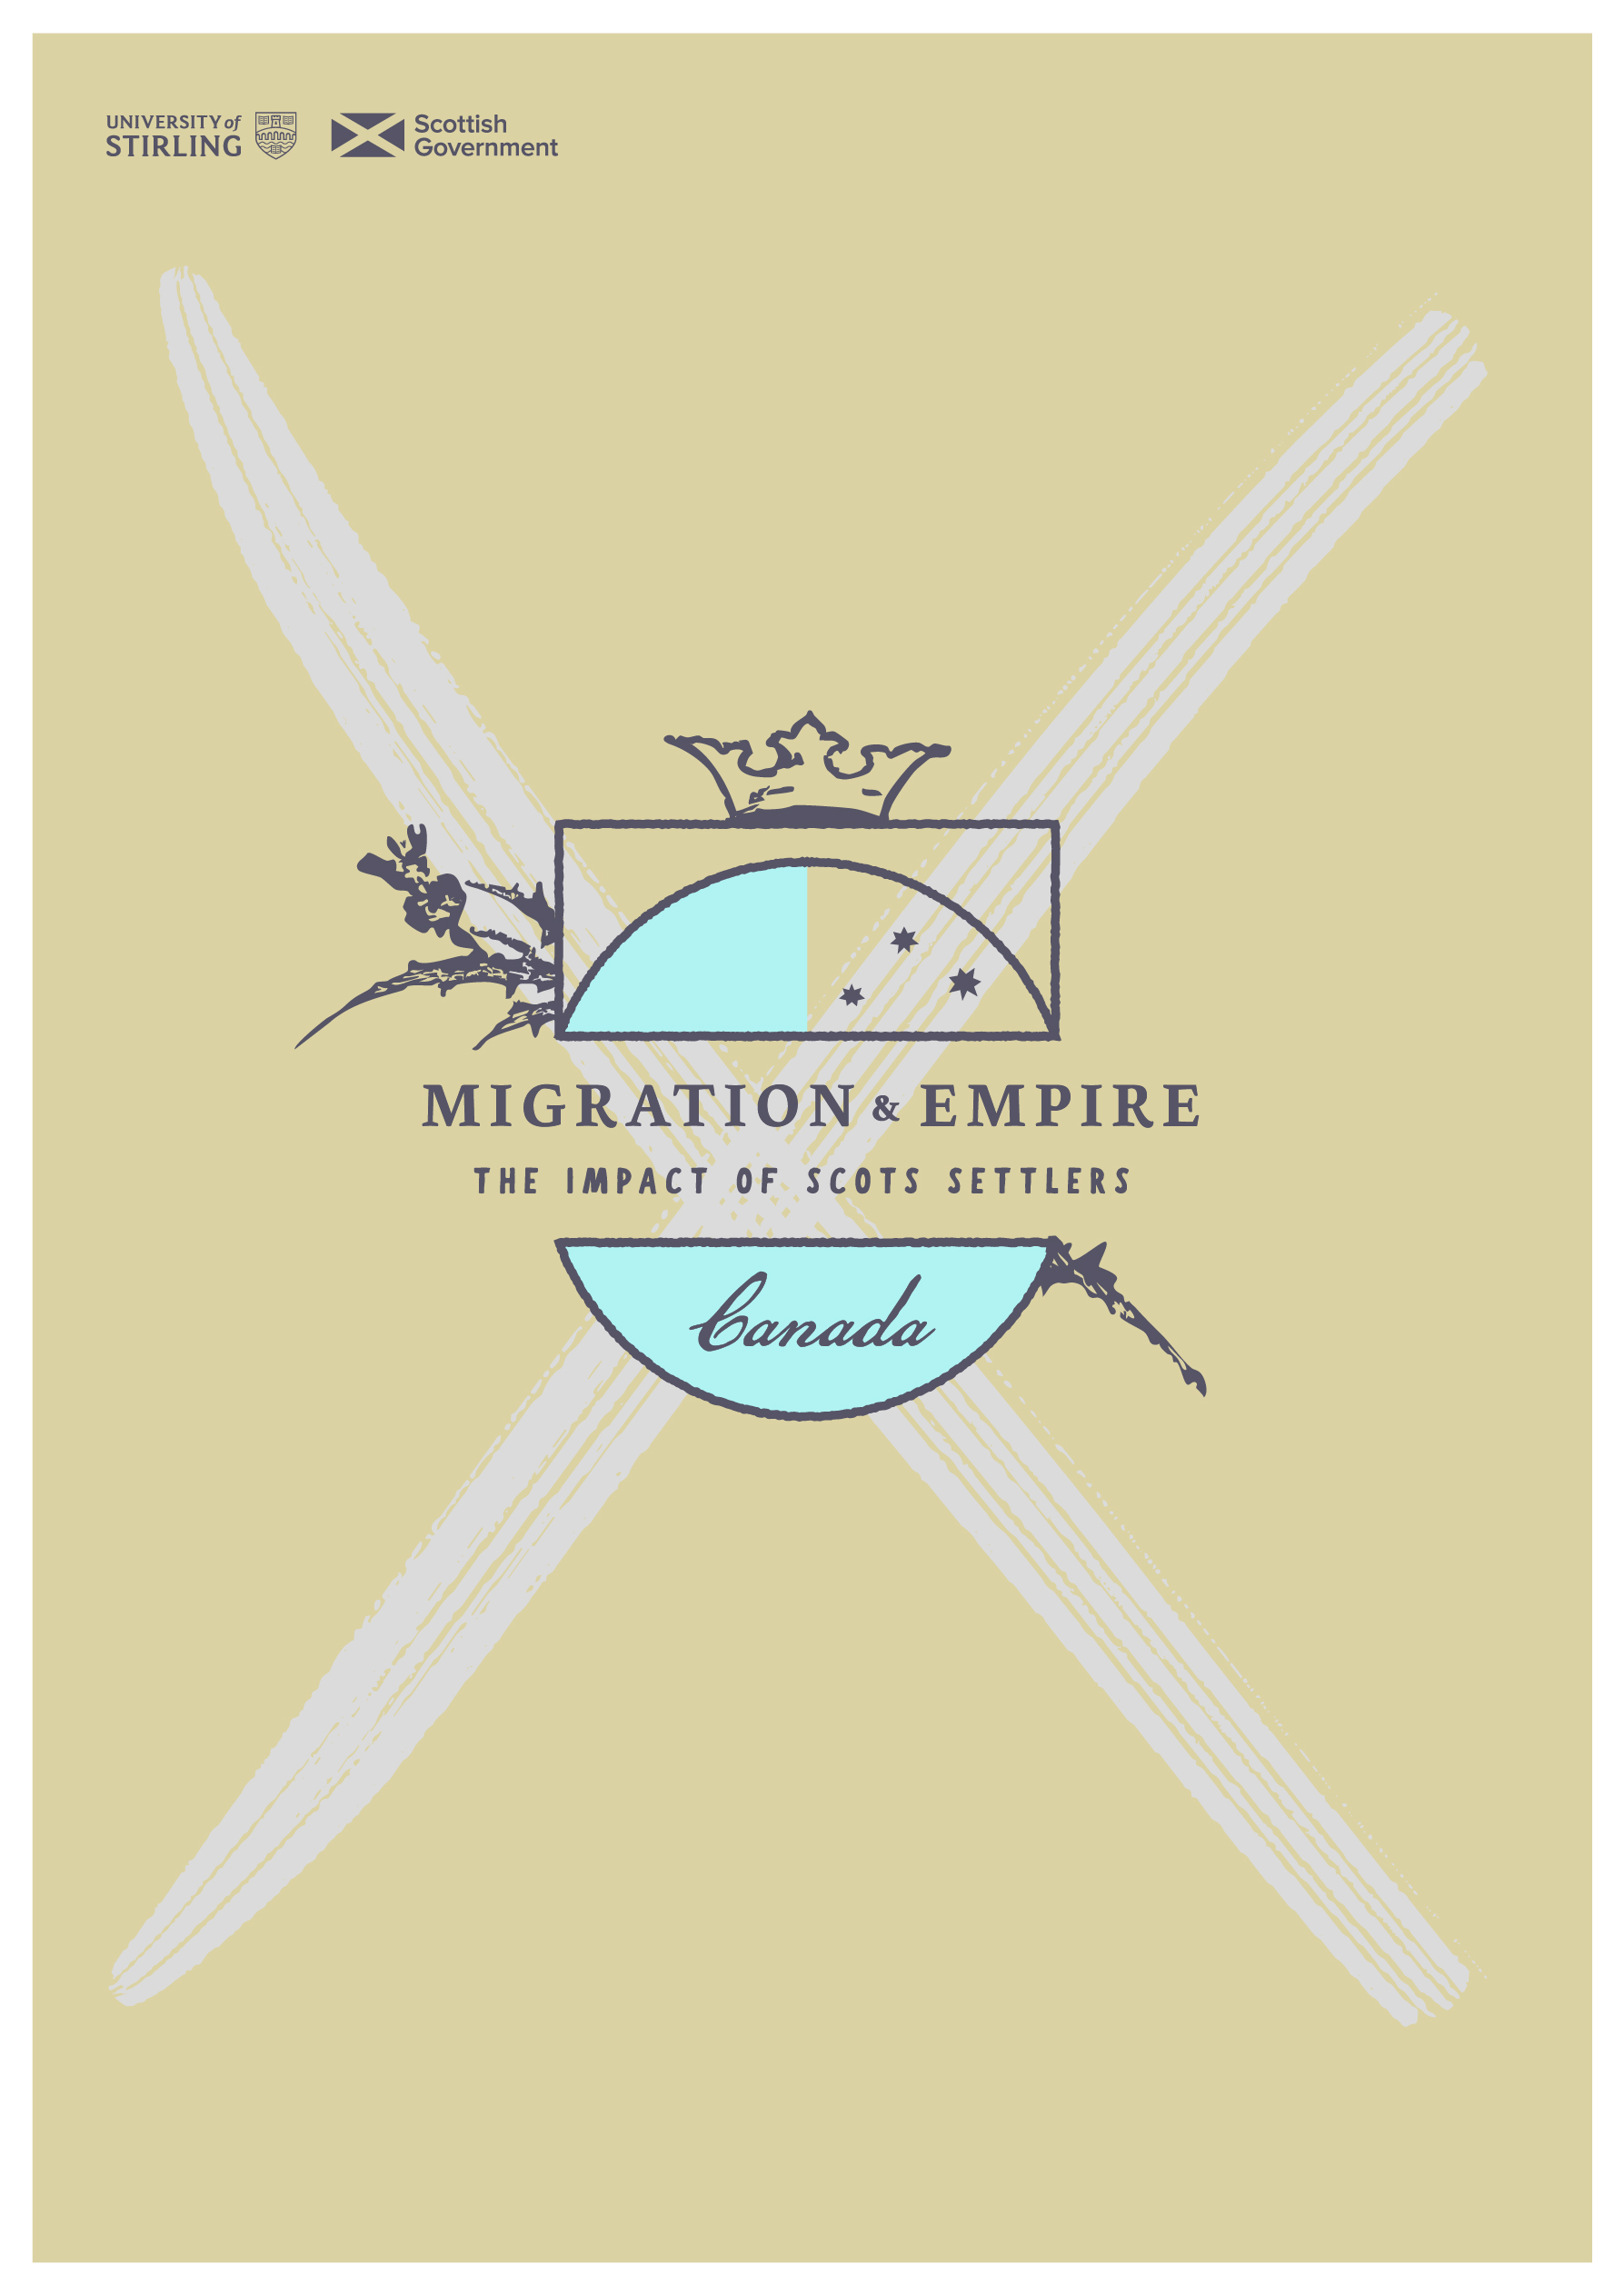
sath.org.uk/migration-and-empire
Introduction to the history of European settlement in Canada

Introduction to the history of European settlement in Canada. Adapted from ‘Highlights from the Report of the Royal Commission on Aboriginal Peoples’, Government of Canada
Stage 1: Separate Worlds
Before 1500, Aboriginal societies in the Americas and non-Aboriginal societies in Europe developed along separate paths. The variety in their languages, cultures and social traditions was enormous. On both sides of the Atlantic, independent peoples with evolving systems of government – though smaller and simpler than today – flourished and grew.
‘America, separated from Europe by a wide ocean, was inhabited by a distinct people, divided into separate nations, independent of each other and the rest of the world, having institutions of their own, and governing themselves by their own laws. It is difficult to comprehend… that the discovery of either by the other should give the discoverer rights in the country discovered which annulled the previous rights of its ancient possessors.’
Chief Justice John Marshall, United States Supreme Court Worcester v. Georgia (1832)
In the southeastern region of North America, the Cherokee were organized into a confederacy of some 30 cities – the greatest of which was nearly as large as imperial London when English explorers first set eyes on it.
In northern North America, Aboriginal cultures were shaped by environment and the evolution of technology:
- The plentiful resources of sea and forest enabled west coast peoples to build societies of wealth and sophistication.
- On the prairies and northern tundra, Aboriginal peoples lived in close harmony with vast, migrating herds of buffalo and caribou.
- In the forests of central Canada, Aboriginal peoples harvested wild rice from the marshes and grew corn, squash and beans beside the river banks, supplementing their crops by fishing, hunting and gathering.
- On the east coast and in the far north, the bounty of the sea and land – and their own ingenuity – enabled Aboriginal peoples to survive in harsh conditions.

The Americas were not, as the Europeans told themselves when they arrived, terra nullius – empty land.
Whereas it is just and reasonable, and essential to Our Interests and the Security of Our Colonies, that the several Nations or Tribes of Indians, with whom we are connected and who live under Our Protection, should not be molested or disturbed in the Possession of such parts of Our Dominions and Territories as, not having been ceded to or purchased by Us, are reserved for them, or any of them, as their Hunting Grounds…
Royal Proclamation of 1763
Stage 2: Nation-to-Nation Relations
Encounters between Aboriginal and non-Aboriginal people began to increase in number and complexity in the 1500s. Early contact unfolded roughly as follows:
- Mutual curiosity and apprehension.
- An exchange of goods, tentative at first, then expanding steadily.
- Barter and trade deals, friendships and intermarriage, creating bonds between individuals and families.
- Military and trade alliances, creating bonds between and among nations.

Non-Aboriginal accounts of early contact tend to emphasize the 'discovery' and 'development' of North America by explorers from Europe (mainly France and Britain). But this is a one-sided view. For at least 200 years, the newcomers would not have been able to survive the rigours of the climate, succeed in their businesses (fishing, whaling, fur trading), or dodge each other's bullets without Aboriginal help.
Cautious co-operation, not conflict, was the theme of this period, which lasted into the eighteenth or nineteenth century, depending on the region. For the most part, Aboriginal and non-Aboriginal people saw each other as separate, distinct and independent. Each was in charge of its own affairs. Each could negotiate its own military alliances, its own trade agreements, its own best deals with the others.
Co-operation was formalized in two important ways:
- In treaties, which were set down in writing by British, French and other European negotiators and solemnized by Aboriginal nations in oral and visual records, including wampum belts.
- In the extraordinary document known as the Royal Proclamation of 1763

Treaty Making
Treaty making among Aboriginal peoples dates back to a time long before Europeans arrived. Aboriginal nations treated among themselves to establish peace, regulate trade, share use of lands and resources, and arrange mutual defence. Through pipe smoking and other ceremonies, they gave these agreements the stature of sacred oaths.
European traditions of treaty making date to Roman times, but in the seventeenth century, they took on new importance. They became the means for the newborn states of Europe to control their bickering and warfare – indeed, to end it for long periods. Treaties were a way of recognizing each other's independence and sovereignty and a mark of mutual respect.
In the colonies that became Canada, the need for treaties was soon apparent. The land was vast, and the colonists were few in number. They feared the might of the Aboriginal nations surrounding them. Colonial powers were fighting wars for trade and dominance all over the continent. They needed alliances with Indian nations.
Over several hundred years, treaty making was used to keep the peace and share the wealth of Canada.
The British colonial government's approach to the treaties was schizophrenic. By signing, British authorities appeared to recognize the nationhood of Aboriginal peoples and their equality as nations. But they also expected First Nations to acknowledge the authority of the monarch and, increasingly, to cede large tracts of land to British control – for settlement and to protect it from seizure by other European powers or by the United States.
The Aboriginal view of the treaties was very different. They believed what the king's men told them, that the marks scratched on parchment captured the essence of their talks. They were angered and dismayed to discover later that what had been pledged in words, leader to leader, was not recorded accurately. They accepted the monarch, but only as a kind of kin figure, a distant 'protector' who could be called on to safeguard their interests and enforce treaty agreements. They had no notion of giving up their land, a concept foreign to Aboriginal cultures.
‘In my language, there is no word for “surrender”. There is no word. I cannot describe 'surrender' to you in my language, so how do you expect my people to [have] put their X on “surrender”?’
Chief Francois Paulette, Treaty 8 Tribal Council, Yellowknife, Northwest Territories
The Two Row Wampum, a belt commemorating a 1613 treaty between the Mohawk and the Dutch, captures the understanding of Aboriginal peoples – treaties were statements of peace, friendship, sharing or alliance, not submission or surrender:
‘A bed of white wampum symbolizes the purity of the agreement. There are two rows of purple, and those two rows represent the spirit of our ancestors. Three beads of wampum separating the two purple rows symbolize peace, friendship and respect. The two rows of purple are two vessels travelling down the same river together. One, a birch bark canoe, is for the Indian people, their laws, their customs and their ways. The other, a ship, is for the white people and their laws, their customs and their ways. We shall each travel the river together, side by side, but in our own boat. Neither of us will try to steer the other's vessel.’
The Royal Proclamation
The Royal Proclamation of 1763 was a defining document in the relationship between Aboriginal and non-Aboriginal people in North America. Issued in the name of the king, the proclamation summarized the rules that were to govern British dealings with Aboriginal people – especially in relation to the key question of land.
It is a complex legal document, but the central messages of the proclamation are clear in its preamble. Aboriginal people were not to be "molested or disturbed" on their lands. Transactions involving Aboriginal land were to be negotiated properly between the Crown and ‘assemblies of Indians’. Aboriginal lands were to be acquired only by fair dealing: treaty, or purchase by the Crown.
The proclamation portrays Indian nations as autonomous political entities, living under the protection of the Crown but retaining their own internal political authority. It walks a fine line between safeguarding the rights of Aboriginal peoples and establishing a process to permit British settlement. It finds a balance in an arrangement allowing Aboriginal and non-Aboriginal people to divide and share sovereign rights to the lands that are now Canada.
More than a hundred years later, in 1867, the arrangement we know as Confederation would also allow for power sharing among diverse peoples and governments. But the first confederal bargain was with First Peoples.

Stage 3: Respect Gives Way to Domination
In the 1800s, the relationship between Aboriginal and non-Aboriginal people began to tilt on its foundation of rough equality. The number of settlers was swelling, and so was their power. As they dominated the land, so they came to dominate its original inhabitants. They gained power as a result of four changes that were transforming the country:
- The population mix was shifting to favour the settlers. Immigration continued to add to their numbers, while disease and poverty continued to diminish Aboriginal nations. By 1812, immigrants outnumbered Indigenous people in Upper Canada by a factor of ten to one.
- The fur trade was dying, and with it the old economic partnership between traders and trappers. The new economy was based on timber, minerals, agriculture. It needed land – not labour – from Aboriginal people, who began to be seen as 'impediments to progress' instead of valued partners.
- Colonial governments in Upper and Lower Canada no longer needed Aboriginal nations as military allies. The British had defeated all competitors north of the 49th parallel. South of it, the United States had fought for self-government and won. The continent was at peace.
- An ideology proclaiming European superiority over all other peoples was taking hold. It provided a rationale for policies of domination and assimilation, which slowly replaced partnership in the North American colonies. These policies gradually increased in number, having a bitter effect on Aboriginal people.

‘History has not been written yet from the Indian point of view.’
Violet Soosay, Montana First Nation community, Hobbema, Alberta
Ironically, the transformation from respectful coexistence to domination by non-Aboriginal laws and institutions began with the main instruments of the partnership: the treaties and the Royal Proclamation of 1763. These documents offered Aboriginal people not only peace and friendship, respect and rough equality, but also 'protection'.
Protection was the leading edge of domination. At first, it meant preservation of Aboriginal lands and cultural integrity from encroachment by settlers. Later, it meant 'assistance', a code word implying encouragement to stop being Aboriginal and merge into the settler society.
Protection took the form of compulsory education, economic adjustment programs, social and political control by federal agents, and much more. These policies, combined with missionary efforts to civilize and convert Indigenous people, tore wide holes in Aboriginal cultures, autonomy and feelings of self-worth. One of them, the Gradual Civilization Act (1857), was brought in by the first Prime Minister of Canada, Sir John A. Macdonald. He was born in Glasgow and his family came to Canada when he was 5 years old. The Gradual Civilization Act paved the way for later legislation such as the Indian Act (1876) which regulated the status of Indigenous peoples.
‘[The Indian Act] has… deprived us of our independence, our dignity, our self-respect and our responsibility.’
Katherine June Delisle, Kanien'kehaka First Nation, Kahnawake, Quebec
Policies of Domination and Assimilation
No Canadian acquainted with the policies of domination and assimilation wonders why Aboriginal people distrust the good intentions of non-Aboriginal people and their governments today.
The Doctrine of Assimilation
The doctrine of assimilation was based on four dehumanizing (and incorrect) ideas about Aboriginal peoples and their cultures:
- that they were inferior peoples that they were unable to govern themselves and that colonial and Canadian authorities knew best how to protect their interests and well-being
- that the special relationship of respect and sharing enshrined in the treaties was an historical anomaly with no more force or meaning
- that European ideas about progress and development were self-evidently correct and could be imposed on Aboriginal people without reference to any other values and opinions – let alone rights – they might possess
- Colonial and Canadian governments established 'reserves' of land for Aboriginal people – usually of inadequate size and resources – with or without treaty agreements. The system began in 1637, with a Jesuit settlement at Sillery in New France. Reserves were designed to protect Aboriginal people and preserve their ways, but operated instead to isolate and impoverish them.
- In 1857, the Province of Canada passed an act to ‘Encourage the Gradual Civilization of the Indian Tribes’. It provided the means for Indians "of good character" (as determined by a board of non-Aboriginal examiners) to be declared, for all practical purposes, non-Indian. As non-Indians, they were invited to join Canadian society, bringing a portion of tribal land with them. Only one man, Elias Hill, a Mohawk from the Six Nations, is known to have accepted the invitation.
- By the beginning of the nineteenth century, significant numbers of Métis people were living in almost all parts of Canada. Their heritage of Aboriginal, French and British cultures, combined with their experience as intermediaries between the factions competing for trade and territory, resulted in their emergence as distinct peoples with their own culture, institutions and lifeways.

‘The promises we have to make to you are not for today only, but for tomorrow, and not only for you but for your children born and unborn. And the promises we make will be carried out as long as the sun shines above and the water flows in the ocean.’
Alexander Morris, Lieutenant Governor of Manitoba and the North-West Territories.
Address to the Cree and Salteaux, Fort Qu'Appelle (1874)
But British and Canadian policy toward Métis people was dismissive. They were not 'Indians', and they were not legitimate settlers. The usual practice was to declare them 'squatters' and edge them off the land they were farming when preferred settlers moved in.
Under Louis Riel, the Métis of the Red River Valley struggled for their own land and government. They were promised both in the Manitoba Act of 1870, but those promises were later denied. Many moved further west and north, where they again fought for land and political recognition. In the spring of 1885 their forces were crushed at Batoche by a military expedition sent by Ottawa. The people were dispersed again, and to this day, their claims for a secure land base and their own forms of government have not been settled.

Our Indian legislation generally rests on the principle that the Aborigines are to be kept in a condition of tutelage and treated as wards or children of the state… It is clearly our wisdom and our duty, through education and other means, to prepare him for a higher civilization by encouraging him to assume the privileges and responsibilities of full citizenship.
Annual Report of the Department of the Interior (1876)
Confederation, declared in 1867, was a new partnership between English and French colonists to manage lands and resources north of the 49th parallel. It was negotiated without reference to Aboriginal nations, the first partners of both the French and the English. Indeed, newly elected Prime Minister John A. Macdonald announced that it would be his government's goal to ‘do away with the tribal system, and assimilate the Indian people in all respects with the inhabitants of the Dominion.’
The British North America Act, young Canada's new constitution, made "Indians, and Lands reserved for the Indians" a subject for government regulation, like mines or roads. Parliament took on the job with vigour – passing laws to replace traditional Aboriginal governments with band councils with insignificant powers, taking control of valuable resources located on reserves, taking charge of reserve finances, imposing an unfamiliar system of land tenure, and applying non-Aboriginal concepts of marriage and parenting.
These laws, and others, were codified in the Indian Acts of 1876, 1880, 1884 and later. The Department of the Interior (later, Indian Affairs) sent Indian agents to every region to see that the laws were obeyed.
- In 1884, the potlatch ceremony, central to the cultures of west coast Aboriginal nations, was outlawed. In 1885, the sun dance, central to the cultures of prairie Aboriginal nations, was outlawed. Participation was a criminal offence.
- In 1885, the Department of Indian Affairs instituted a pass system. No outsider could come onto a reserve to do business with an Aboriginal resident without permission from the Indian agent. In many places, the directives were interpreted to mean that no Aboriginal person could leave the reserve without permission from the Indian agent. Reserves were beginning to resemble prisons.
- In 1849, the first of what would become a network of residential schools for Aboriginal children was opened in Alderville, Ontario. Church and government leaders had come to the conclusion that the problem (as they saw it) of Aboriginal independence and 'savagery' could be solved by taking children from their families at an early age and instilling the ways of the dominant society during eight or nine years of residential schooling far from home. Attendance was compulsory. Aboriginal languages, customs and habits of mind were suppressed. The bonds between many hundreds of Aboriginal children and their families and nations were bent and broken, with disastrous results.

During this stage in the changing relationship, Canadian governments moved Aboriginal communities from one place to another at will. If Aboriginal people were thought to have too little food, they could be relocated where game was more plentiful or jobs might be found. If they were suffering from illness, they could be relocated to new communities where health services, sanitary facilities and permanent housing might be provided. If they were in the way of expanding agricultural frontiers, or in possession of land needed for settlement, they could be relocated 'for their own protection'. If their lands contained minerals to be mined, forests to be cut, or rivers to be dammed, they could be relocated 'in the national interest'.
In each world war, more than 3,000 registered Indians and unrecorded numbers of Inuit, Métis and non-status Indian people volunteered for the Canadian Armed Forces. Their contributions of life, limb and money were appreciated at home, and most of the volunteers found acceptance on the battlefield. Hundreds lost their lives there or were wounded.
Those who survived asked for no special honours, but they expected to be treated as other war veterans were on their return to Canada. They were not. They were denied many of the benefits awarded to other vets. Land was taken from their reserves and used 'for military purposes' or awarded to non-Aboriginal veterans. Those left alive today are still seeking recognition for their part in the war effort and compensation for their later losses.
Treaties were still the chosen means of managing the relationship. But the treaty process was increasingly strained by conflicting interpretations of their purpose. The purpose of the treaties, in Aboriginal eyes, was to work out ways of sharing lands and resources with settlers, without any loss of their own independence. But the representatives of the Crown had come to see the treaties merely as a tool for clearing Aboriginal people off desirable land.
To induce First Nations to sign, colonial negotiators continued to assure them that treaty provisions were not simply agreed, but guaranteed to them – for as long as the sun shone and the rivers flowed.

Stage 4: Renewal and Renegotiation
Policies of domination and assimilation battered Aboriginal institutions, sometimes to the point of collapse. Poverty, ill health and social disorganization grew worse. Aboriginal people struggled for survival as individuals, their nationhood erased from the public mind and almost forgotten by themselves.
"The fact is that when the settlers came, the Indians were there, organized in societies and occupying the land as their forefathers had done for centuries. This is what Indian title means…"
Supreme Court of Canada, Calder v. Attorney General of British Columbia (1973)
Resistance to assimilation grew weak, but it never died away. In the fourth stage of the relationship, it began to grow into a political movement. One stimulus was the federal government's White Paper on Indian policy, issued in 1969.
The White Paper proposed to abolish the Indian Act and all that remained of the special relationship between Aboriginal people and Canada – offering instead what it termed equality. First Nations were nearly unanimous in their rejection. They saw this imposed form of 'equality' as a coffin for their collective identities – the end of their existence as distinct peoples. Together with Inuit and Métis, they began realize the full significance of their survival in the face of sustained efforts to assimilate them. They began to see their struggle as part of a worldwide human rights movement of Indigenous peoples. They began to piece together the legal case for their continuity as peoples – nations within Canada – and to speak out about it.
They studied their history and found evidence confirming that they have rights arising from the spirit and intent of their treaties and the Royal Proclamation of 1763. They took heart from decisions of Canadian courts, most since 1971, affirming their special relationship with the Crown and their unique interest in their traditional lands. They set about beginning to rebuild their communities and their nations with new-found purpose.
‘The relationship between the government and Aboriginals is trust-like rather than adversarial, and… contemporary recognition and affirmation of Aboriginal rights must be defined in light of this historic relationship.’
Supreme Court of Canada, R. v. Sparrow (1990)

The strong opposition of Aboriginal people to the White Paper's invitation to join mainstream society took non-Aboriginal people by surprise. The question of who Aboriginal people are and what their place is in Canada became central to national debate.
A dozen years of intense political struggle by Aboriginal people, including appeals to the Queen and the British Parliament, produced an historic breakthrough. "Existing Aboriginal and treaty rights" were recognized in the Constitution Act, 1982.
This set the stage for profound change in the relationship among the peoples of Canada, a change that most governments have nevertheless found difficult to embrace.

