SATH Autumn Conference 2018

A Year of Anniversaries
Saturday 17th November 2018
The High School of Glasgow, 637 Crow Road, Glasgow, Lanarkshire, G13 1PL
09.30-9.55 Registration, History Fayre,
Tea & coffee available.

10.00-10.10 Welcome/Presentation of Awards.
Chris MacKay, SATH President

Fiona Malcolm of Braes High will give a brief overview of the Srebrenica Project.

10.25- 11.20 Saul David: “Foch, Haig and the 100 Days Offensive”
Saul will look at the last acts of the Great War on the Western Front.

Saul David is a historian, broadcaster and the author of several critically-acclaimed works of fiction and non-fiction.

https://sauldavid.co.uk

11.20- 11.40 Interval – tea and coffee

11.40- 12.30 Stephen Green - Higher History.
Stephen will outline the recent changes to the new Higher in History. He will also take questions.
Do you have a question you would like to ask about the higher? If so please write it in the space provided on the signup sheet.

12.30 – 13.30 Networking Lunch and History Fayre
Tea & coffee available in the hall

13.30 – 14.20 Martin Pugh – The Liberal Reforms 1906 – 1914. Martin will discuss the impact of the reforms upon the British people.

http://martindpugh.com/
14.20 – 15.00 Options

      - Workshop 1. Remembering Srebrenica – Fiona Malcolm & Robin McPherson will highlight resources and approaches that can be used in the classroom.

      - Workshop 2. The Statistical Accounts of Scotland online- Aileen Robb and Núria Ruiz will introduce new resources for use in the classroom

      - Workshop 3. Lynne Robertson Education Scotland - The BGE & Benchmarks – An opportunity to engage with Lynne and discuss the latest updates to the BGE.

      - Workshop 4. Approaches to Sources – Claire Wood will lead a practical workshop focussed on creating source questions and marking instructions for use in a higher classroom. The workshop will cater for the three biggest topics: Wars of Independence; Migration and Empire and the First World War. Participants are invited to bring along any questions and marking instructions that have been generated; it will be chance to discuss and share resources.

15.00 Plenary and close-Chris MacKay, SATH President

Saul David
His history books include The Indian Mutiny (shortlisted for the Westminster Medal for Military Literature), Zulu (a Waterstone's Military History Book of the Year), Victoria's Wars and All The King's Men. He has also written two bestselling novels, Zulu Hart and Hart of Empire.

His latest work of non-fiction, Operation Thunderbolt: Flight 139 and the Raid on Entebbe Airport was an Amazon UK History Book of the Year for 2015. The film rights were bought by Hollywood film company Participant Media and used in the making of the motion picture 'Entebbe', filmed on location in Malta and London from November 2016 to January 2017. The film stars Rosamund Pike, Daniel Brühl and Eddie Marsan.

Saul is Professor of Military History at the University of Buckingham, and Programme Director for the university's London-based MA in Military History by Research.
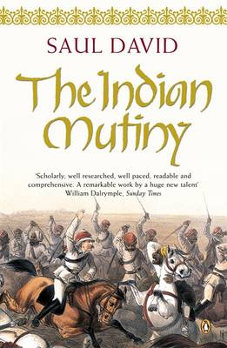

Martin Pugh
Martin graduated in modern history and politics in 1969 and then spent the years 1969-71 on Voluntary Service Overseas as lecturer in European history at the Aligarh Muslim University in India. After returning to Britain he completed research for his Ph.D. on 'The background to the 1918 Representation of the People Act' at Bristol University and the Institute of Historical Research, London University, from 1971 to 1974. He has published a number of books which include: The Making of Modern British Politics, 1867-1945, The Tories and the People, 1880-1935, Lloyd George, Women and the Women's Movement in Britain 1914-1959, The March of the Women: a revisionist analysis of the campaign for women’s suffrage, 1866-1914, The Pankhursts and “We Danced All Night": A Social History of Britain Between the Wars
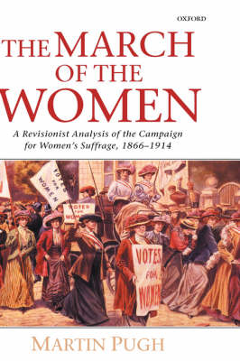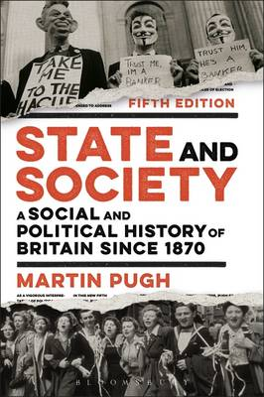

SATH Fee: £75; (students £25 & probationer teachers £30)
Departmental Rate £170 – 3 teachers

Conference fee MUST be paid in advance of the conference.
We can invoice if required!
________________________________________________________
SATH Autumn Conference 2018 Registration Form

Sign up online here –
https://sath2018.eventbrite.co.uk

Or complete and return this form.

Name(s):
School (if teacher):
Address
Email & Phone
Contact Name/email for payment
Include as a SATH Member (now free of charge)

CPD certificate required

Invoice required

Choice of Workshop (Please Circle One) 1 2 3 4

Do you have any special dietary requirements? ___________________________________________

Please return to Chris Mackay SATH President by November 10th 2018. All cheques should be made payable to “Scottish Association of Teachers of History”.
Email: cm@hsog.co.uk

Postal address:
Chris MacKay
SATH President
History Department
The High School of Glasgow
637 Crow Road
Glasgow
Lanarkshire
G13 1PL
Tel: 0141 954 9628

Do you have a question you would like to ask about the revised course assessment at Higher? Please write your question in the space below or email me at cm@hsog.co.uk. This will help Stephen to answer as many questions as possible.

