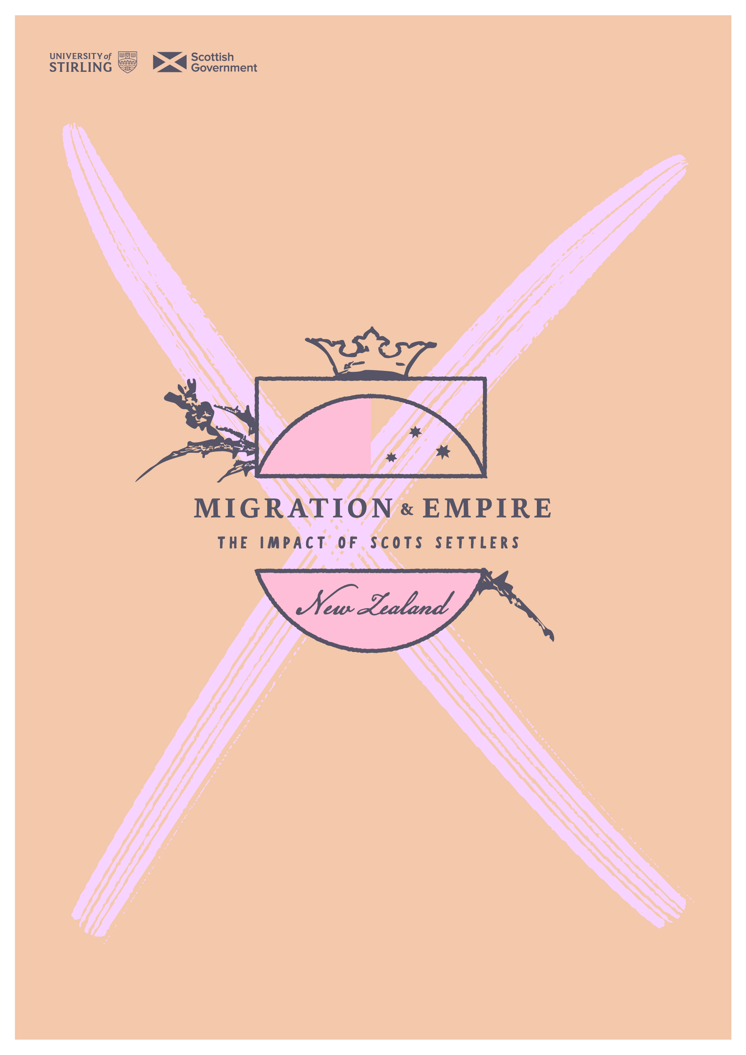

sath.org.uk/migration-and-empire

***Introduction to the history of European settlement in Aotearoa New Zealand***

***Introduction to the history of European settlement in Aotearoa New Zealand. Adapted from NZ History:*** [***https://nzhistory.govt.nz/culture/history-of-new-zealand-1769-1914#heading1***](https://nzhistory.govt.nz/culture/history-of-new-zealand-1769-1914#heading1) ***and The Encyclopedia of New Zealand:*** [**https://teara.govt.nz/en/new-zealand-identity/page-2**](https://teara.govt.nz/en/new-zealand-identity/page-2)

**First contacts**

By the time the first Europeans arrived, Māori had long settled the land, every corner of which came within the interest and influence of a tribal (*iwi*) or sub-tribal (*hapū*) grouping. Abel Tasman was the first of the European explorers known to have reached New Zealand, in December 1642. His only encounter with Māori ended badly, with four of his crew killed and Māori fired upon in retaliation. Tasman named the place we now call Golden Bay ‘Moordenaers’ (Murderers’) Bay. After he left these shores in early January 1643, Tasman’s New Zealand became a ragged line on the world map. The Māori response to this visit is less well-known, with the exception of fragments of oral tradition that were recorded in the 19th century.

It would be 127 years before the next recorded encounter between European and Māori. The British explorer James Cook arrived in Te Tairāwhiti (Poverty Bay) in October 1769. His voyage to the South Pacific was primarily a scientific expedition, but the British were not averse to expanding trade and empire when opportunities arose.

Over the next 60 years contact grew. The overwhelming majority of encounters between European and Māori passed without incident, but when things did turn violent much was made of the killing of Europeans. The attack on the sailing ship *Boyd* in December 1809 was one such example. The incident saw some sailors refer to New Zealand as the ‘Cannibal Isles’, and people were warned to steer clear of the country. Little mention was made of the revenge for the *Boyd* exacted by European whalers, with considerable loss of Māori life. The Anglican Church Missionary Society (CMS) put off its plans to establish the first Christian mission in New Zealand for nearly a decade following these events.

Contact with sealers and whalers – who began arriving in hundreds in the closing decades of the 18th century – and with traders looking to develop new markets, was largely confined to the Far North and the ‘Deep South’. Māori living in the interior had little or no contact with Europeans before 1840.

Those hapū and iwi who did encounter Europeans were often willing and able participants in the trade that quickly developed. Various intermediaries (*kaiwhakarite*) – people from one culture who lived with the other – were important in helping establish and maintain trade networks as well as bridging the cultural gap. Māori women were often used to keep Pākehā (non-Māori) men in the community. Māori also worked as crew members on ships operating between Port Jackson (Sydney) and the Bay of Islands. Much inter-racial contact was ‘strained through Sydney first’. Māori were receptive to many of the new ideas that came with contact. Literacy, introduced by the Christian missionaries, became an increasingly important element of Māori culture from the 1830s.

By the 1830s, the British government was being pressured to reduce lawlessness in the country and to settle here before the French, who were considering New Zealand as a potential colony.

**Treaty of Waitangi**

On 6 February 1840 at Waitangi, William Hobson — New Zealand’s first Governor — invited assembled Māori chiefs to sign a treaty with the British Crown.

The treaty was taken all around the country — as far south as Foveaux Strait — for signing by local chiefs. More than 500 chiefs signed the treaty that is now known as the Treaty of Waitangi (*Te Tiriti o Waitangi*).

New Zealand’s system of government is strongly influenced by the Treaty of Waitangi. Top of Form

Bottom of Form

The Treaty is the agreement signed by representatives of the Queen of England and leaders of most Māori tribes. Following the signing of the treaty, in May 1840, the Crown declared its sovereignty over the islands of New Zealand, and the latter became its colony.

The settlement of Waitangi in Northland is still the focus of events when New Zealand celebrates the signing with a national holiday on February 6 each year.

**Why the Treaty is important**

The Treaty governs the relationship between Māori - the *tangata whenua* (indigenous people) - and everyone else, and ensures the rights of both Māori and Pākehā (non-Māori) are protected. It does that by:

* accepting that Māori *iwi* (tribes) have the right to organise themselves, protect their way of life and to control the resources they own
* requiring the Government to act reasonably and in good faith towards Māori
* making the Government responsible for helping to address grievances
* establishing equality and the principle that all New Zealanders are equal under the law.

There were two versions of the treaty, one in English and the other in Māori, and neither version of the treaty was a translation of the other. The ambiguity of the treaty became a source of considerable conflict. ‘Under the English version, the crown assumed sovereignty over the territory of New Zealand’ and the Māori version used the word *rangatiratanga* which translates as ‘chieftainship’ or ‘authority’ which resulted in wavering views over land rights and ownership. Tensions triggered localised conflicts that intensified to form a Māori rebellion that led to confiscation of 6,200 square miles of land under the New Zealand Settlements Act in 1863.

**New Zealand Wars**

The New Zealand Wars were a series of mid-19th-century campaigns involving some iwi Māori and government forces, which included British and colonial troops and their Māori allies. The two major periods of conflict were the mid-1840s and the 1860s.

During this period, British and (increasingly) colonial troops fought to ‘open up’ the North Island for settlement. Contested understandings of sovereignty were inflamed by decreasing Māori willingness to sell land and increasing pressure for land for settlement as the European population grew rapidly.

Around 3000 people were killed during these wars – the majority of them Māori. While many died defending their land, others allied themselves with the colonists, often to achieve tribal goals at the expense of other *iwi*.

Among other impacts, the New Zealand Wars warped the Māori identity. Māoris were often represented as savage, which was an elaborate social distinction of the *Pākehā* in order for them to justify and exercise control. This shows race to be a social and historical construct where imperialist dimensions have fabricated a negative paradigm of the Māori that has been carried through to today.

**Naming the wars**

Though ‘New Zealand Wars’ is the most common collective name for these campaigns, a number of others have been used. Originally Europeans called them the Māori wars. This echoed the tendency of the British to name wars after their enemies – as in Boer War and Zulu War. In the late 1960s thought was given to renaming the wars. One popular suggestion was land wars, due to the importance of land in the disputes. Another was Anglo–Māori wars to indicate the two major groups involved.

**1840s**

The first series of wars took place in the 1840s, when Māori were a majority of the population, although *Pākehā* dominated the towns. A precursor to the wars was the 1843 Wairau incident, in which Nelson settlers clashed with *Ngāti Toa* at Tuamarino (now known as Tuamarina) over a land dispute. The 1840s wars began with fighting between *Ngāpuhi* and government forces at Kororāreka (Russell) in 1845. A series of battles were fought in the Bay of Islands until early 1846. Later that year there was fighting between government forces and Māori in Wellington, and there were skirmishes in Whanganui in 1847.

**1860s and 1870s**

The most sustained and widespread campaign was the clash between the British Empire and the *Kīngitanga* (Māori King movement) in Taranaki, Waikato and Bay of Plenty between 1860 and 1864. The last period of the wars, from 1864 to 1872, was largely fought by colonial troops and their Māori allies against followers of Māori prophetic leaders. These wars occurred in Taranaki, East Coast and the central North Island.

**Confiscations and Impact**

After the wars, significant areas of Māori land in the North Island were confiscated by the government. Reactions against the confiscations saw a period of continued tension. In Taranaki, peaceful protests against land confiscations continued.

[Māori & Pākehā population, 1838-1901](https://nzhistory.govt.nz/node/52213)

**Economic expansion**

As war stalled progress in the North Island, the South Island became the mainstay of the colonial economy. Wool made Canterbury the country’s wealthiest province, and the discovery of gold in Central Otago in 1861 helped Dunedin become New Zealand’s largest town. The thousands of young men who rushed to the colony hoping to make their fortune followed the gold from Otago to the West Coast and later to Thames in the North Island. Few struck it rich, but the collective value of the gold that was discovered stimulated the economy.

These developments attracted a young, mobile and male-dominated population. Both provincial and central governments believed that long-term growth and progress depended on the order and stability offered by family life. Various schemes were developed to attract female migrants and families to New Zealand in a bid to help the young society mature.

**Emerging identity**

From 1886 on, the majority of non-Māori people living in New Zealand had been born there. The term ‘New Zealander’ had originally referred to Māori, but now took on a new meaning. However, New Zealand’s identity remained largely contained within an imperial identity. The close economic ties with Britain reinforced the loyalty of New Zealanders to an empire that secured their place in the world. Most Pākehā continued to see themselves as British and referred to Britain as ‘home’.

This loyalty could be seen in New Zealand’s enthusiastic support for Britain when the Second Anglo-Boer War broke out in South Africa in 1899. This was the first time New Zealand troops served overseas. Then-Prime Minister Richard John Seddon proudly confirmed that the ‘crimson tie’ of empire bound New Zealand to the ‘Mother-country’.

When the Commonwealth of Australia was established in 1901, New Zealand declined to become its sixth state. Federation with Australia was rejected for a number of reasons, not least because New Zealand aspired to ‘identity, status and a grander future’. Some feared federation might put New Zealand’s social reforms at risk, while others believed New Zealand represented a better ‘type of Britisher’, given the ‘convict stain’ of Australia’s origins.

Federation ultimately consolidated national identity on both sides of the Tasman and strengthened the view that New Zealand should not give up its growing independence. Symbols of nationhood emerged, including a [new flag](https://nzhistory.govt.nz/politics/flags-of-new-zealand/maritime-origins) (1902) and a [Coat of Arms](http://www.mch.govt.nz/nz-identity-heritage/coat-arms) (1911)

In 1907 New Zealand became a dominion within the British Empire. Some trumpeted what they saw as a ‘move up’ in the ‘school of British nations’, but in reality little changed. New Zealand was no more and no less independent from Britain than it had been as a self-governing colony.

**Land and cultural identity**

Land has always been central to New Zealanders’ identity. Māori believed that *Papatūānuku*, the earth mother, was the origin of all life. People were born from the land and returned to the land. The word for land (*whenua*) was also the word for placenta. Tribes typically assert their identity in relation to their mountains and rivers.

British navigator James Cook’s three voyages of exploration established a view of New Zealand as a fertile place which could become a site of prosperous European-style agriculture. Writing in 1979, Sydney Parkinson, the artist on Cook’s first voyage, believed that the East Coast ‘with proper cultivation, might be rendered a kind of second Paradise’. Such images were reinforced by 19th-century immigration propaganda designed to attract landless rural labourers to the new country. They were promised a land with a benign climate and productive soil for growing crops.

From the early twentieth century this rural ideal was strengthened by the idea that men and women who worked on New Zealand farms had strength and do-it-yourself ingenuity, in contrast to the decadent and physically inept populations in older countries. This work of the New Zealand settlers turned the majority of the bush into farmland. Even in the early 2000s – although 85% of New Zealanders lived in urban areas – many still thought of themselves as part of a largely rural or agricultural nation.