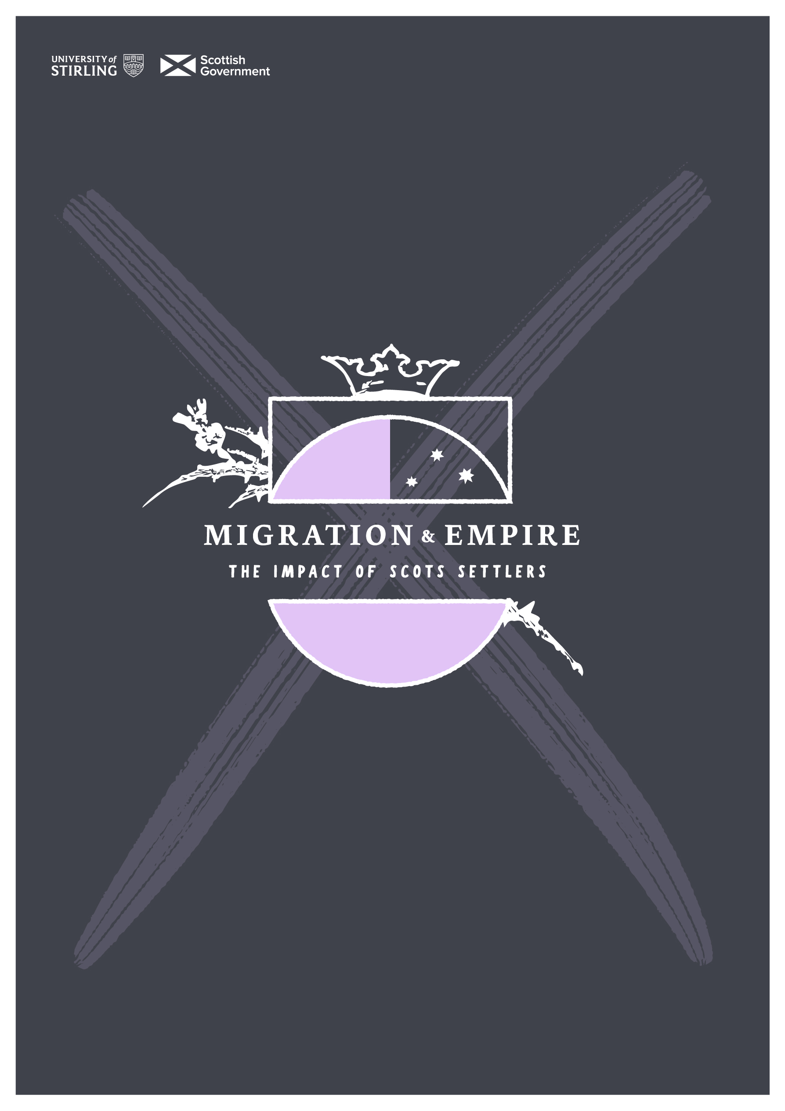

sath.org.uk/migration-and-empire

Glossary

**METISS Glossary**

CANADA

|  |  |  |  |
| --- | --- | --- | --- |
| **Colonial language** | **Why it is inappropriate** | **Post colonial language** | **Why it is currently preferred** |
| Indian | Based on incorrect identification and historically stigmatising | Indigenous, First Nations, Metis, Inuit | More inclusive, recognises specific groups |
| Tribes | Promotes misleading stereotypes | Peoples, Nations |  |
| New World | Implies that prior to European involvement the people, history and advancements of the Americas didn’t exist. Only looks at the area in relation to Europe (Eurocentric) | Americas, North America, South America | Clear and specific |
| **Legislation** | | | |
| Indian Act | Because the Indian Act is based in legislation it is still in use. The document is understood to be flawed and evolving despite ‘guaranteeing’ certain rights to Indigenous Peoples of ‘status’ | | |
| Status | A ‘Status Indian’ is an Indigenous Canadian that fulfils the definition of ‘status’ under the Indian Act and may be eligible to certain benefits, rights and services. | | |
| **Conflicts** | | | |
| Seven Years War | 1756-63 Conflict between Britain and France with Indigenous allies on both sides that played out in North America | | |
| War of 1812 | 1812-1814 Military conflict between Great Britain and the USA with positive lasting effects for Canadians and negatives for Indigenous Peoples | | |

AUSTRALIA

|  |  |  |  |
| --- | --- | --- | --- |
| **Colonial language** | **Why it is inappropriate** | **Post colonial language** | **Why it is currently preferred** |

|  |  |  |  |
| --- | --- | --- | --- |
| Aborigines | Considered offensive | Aboriginal and Torres Strait Islander peoples (note that Aboriginal and Torres Strait Islander people are different groups) | More accurate and does not contain historical stigma |
| Black fellow/ Blackfella | Some Aboriginal people may use this term to refer to themselves but is offensive to be used outside the community | Aboriginal and Torres Strait Islander peoples | More accurate and does not contain historical stigma |
| Myall | Obsolete and pejorative | Aboriginal Australian, Aboriginal and Torres Strait Islander peoples | current |
| Asiatics | Usually used to refer to plant and wildlife not culture or people | Asian | Is more appropriate for people. However, it is better practice to refer to people more specifically e.g. Chinese, Indian, Filipino. |
| Half-caste | Derogatory and racially offensive | Dual- heritage, mixed, biracial, multiracial | More inclusive, respectful of the complexity of identity |

NEW ZEALAND AOTEAROA

|  |  |  |  |
| --- | --- | --- | --- |
| **Colonial language** | **Why it is inappropriate** | **Post colonial language** | **Why it is currently preferred** |
| Māori Wars | Misleading Māori people fought on both sides of this conflict. Some in support of British forces | New Zealand Wars | More accurate in that it recognises the place rather than a people the conflict is associated with. |
| **Māori language terms found in sources** | | | |
| Pākehā. | Māori word for non-Māori peoples, most often in reference to the British | | |
| kūpapa | Māori allies of the crown | | |
| hapū | Subgroup or clan of people. One may have multiple connections to different hapū | | |
| Tāwhiao | Māori king 1860-1894 | | |

Outdated terminology used in historical sources

|  |  |
| --- | --- |
| **Colonial terms** | **Alternatives** |
| natives | Indigenous peoples, Aboriginal people, Torres Strait Islanders First Nations (Australia), Māori (New Zealand) First Nations, Metis, Inuit (Canada) |
| whites | British, Europeans, white settlers |
| blacks | Black people, Aboriginal Peoples (Australia) |
| savages | Indigenous peoples  Literally meaning ‘uncivilised or primitive people’, this is used negatively in colonial times. However, it is important to note that in romantic literature of the 18th century, the ‘noble savage’ was an idea of a person uncorrupted by civilisation representing the inherent goodness of man. |
| Slave owners | enslavers |

Specific Nations mentioned in sources

|  |  |  |
| --- | --- | --- |
| Australia | Canada | New Zealand Aotearoa |
| Wurundjeri | First Nations | Ngāti Toa |
| Boonwarrung | Inuit | Toarangatira |
| Kulin | Metis | NgaiTatara or Ngāti |
| Kuurn Kopan Noot | Mi’kmaq | Ti’maru |
| Gunaikurnai | Metlakathla |  |
| Ngarrindjeri | Haida |  |
| Djargurd Wurrong | Heiltsuk |  |
| Pirt Kopan Noot | Tsimshian |  |
| Kolor |  |  |
| Mopor |  |  |

Other terminology

|  |  |
| --- | --- |
| **Assimilation theory** | The process where one culture becomes more closely related to another over time. This was often the aim of residential schools where Indigenous children were not allowed to maintain their cultural ways |
| **Emigrant** | A person who *moves away from* their home country |
| **Fatal impact Theory** | The settler belief that the Indigenous Peoples would ‘die out’ because of contact with Europeans |
| **Immigrant** | A person who *moves to* a different country |
| **Internalised racism** | The acceptance of negative beliefs and stereotypes by racialised populations about themselves. Can be understood as a type of cultural self-hate |
| **Lang hunger** | Greed for the acquisition of land |
| **Native Minister (New Zealand)** | Historic governmental role created to address relations with Indigenous Peoples. Today the office has been renamed to Minister for Māori Development and is typically held by a representative from the Māori community |
| **Pastoralist** | Sheep or cattle farmer especially (in Australia) |
| **Pastoralism** | Taking care of animals like sheep, cows, or goats to use for things like milk, meat, or wool |
| **Pearler** | A person who dives for or trades in pearls |
| **Protector of the Aborigines** | Governmental role in 17th century Australia recommended to address conflicts between Aboriginal Peoples and white settlers |
| **Reserve** | Lands set aside by government for Indigenous Peoples |
| **Residential schools** | Boarding schools set up by the government for Indigenous children with the aim of assimilating them to white settler culture. In some places like Canada these schools were run by the church. Residential schools were used in the United States, Canada, Australia and New Zealand |
| **Segregation** | The enforced separation of people by ethnic or racial group usually to the disadvantage of the adversely racialised people |
| **Settler capitalism** | The idea that settler colonialism is directly connected to systemised privatisation and profit. |
| **Settler colonialism** | Settler colonialism aims to create a settler society on Indigenous land and exploit the land for settler advantage and also seeks to eliminate Indigenous populations |
| **Social Darwinism** | The idea that people and communities are subject to the laws of natural selection like plants and animals. In the 19th and 20th centuries this theory was used to justify racism, eugenics and imperialism. Today social Darwinism has been largely discredited. |
| **Structural racism** | Policies and practices that perpetuate racial inequality in housing, income, and healthcare etc. |
| **Tacksman** | A person who holds a lease on land and sublets to others. This term is typically used in the context of the 17th century Scottish Highlands. |
| ***Terra nullius*** | A Latin term meaning ‘nobody’s land’. It was a concept used to justify colonisation by the British. |
| **Treaty** | Constitutionally recognised agreements between the Crown and Indigenous peoples |
| **White man’s burden** | The notion that it was the duty of European powers to ‘civilise’ Indigenous peoples by bringing their culture and religion to the rest of the world. ‘The White Man’s Burden’ is also a famous poem by Rudyard Kipling which glorifies colonialism. |